Project Design Phase-II
Technology Stack (Architecture & Stack)
Date | 31 January 3035
Team ID | SWTID-2026-3677
Project Name | Auto Ticket Classification using Flow Designer
Maximum Marks | 4 Marks
Technical Architecture:
The Deliverable shall include the architectural diagram as below and the information as per the table1 & table 2
Example: Order processing during pandemics for offline mode
Reference: https://developer.ibm.com/patterns/ai-powered-backend-system-for-order-processing-during-pandemics/
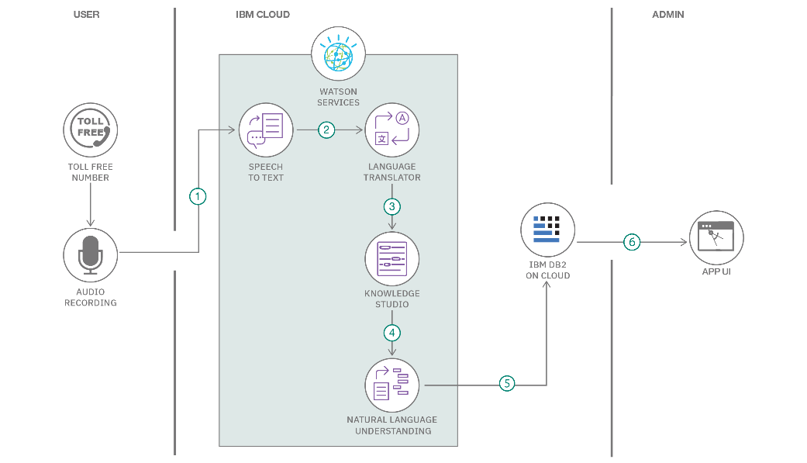 | 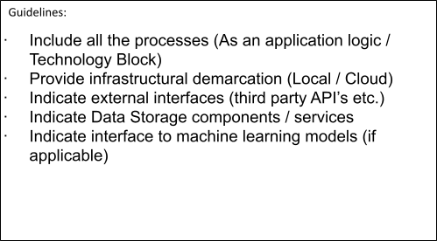

Architecture Diagram: Auto Ticket Classification using Flow Designer
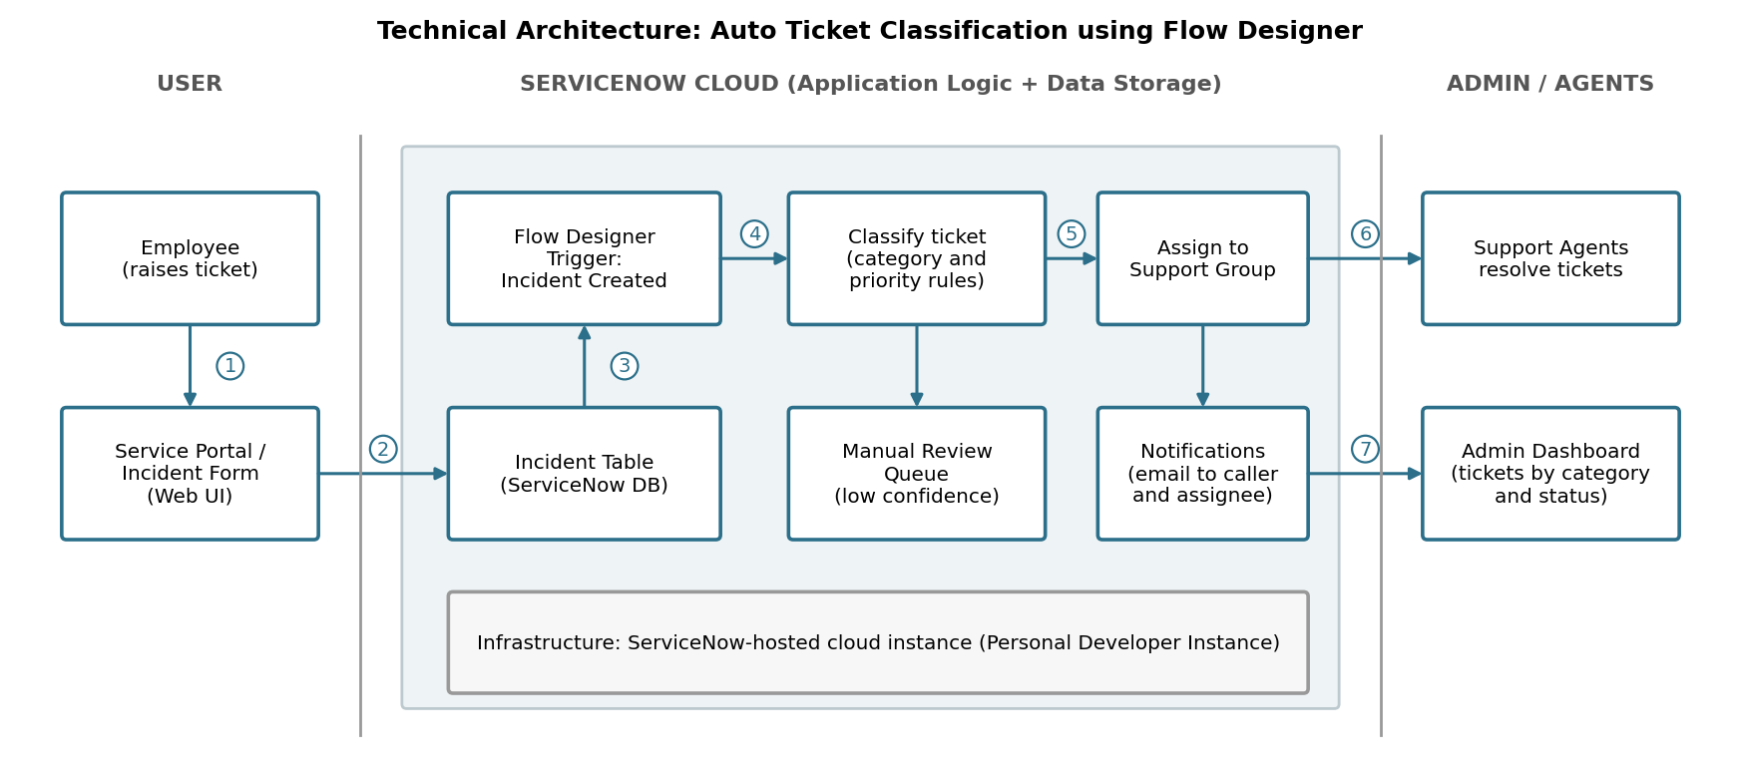

Table-1 : Components & Technologies:
S.No | Component | Description | Technology
1. | User Interface | Employees raise incidents on the Service Portal; agents work tickets in the ServiceNow web UI | ServiceNow Service Portal, Now Experience UI (HTML, CSS, JavaScript)
2. | Application Logic-1 | Flow Designer flow starts when an incident is created and reads its category and short description | ServiceNow Flow Designer (Trigger: Incident Created)
3. | Application Logic-2 | Sets the priority from urgency keywords and assigns the ticket to the matching support group | Flow Designer actions and decision logic (Update Record)
4. | Application Logic-3 | Notifies the caller and assignee and escalates tickets left unassigned | Flow Designer Send Email action, ServiceNow Notifications
5. | Database | Stores incident, assignment group and user records | ServiceNow platform tables (Incident, Group, User)
6. | Cloud Database | Database service on cloud hosting the ServiceNow instance | ServiceNow cloud-managed instance database
7. | File Storage | Ticket attachments | ServiceNow Attachment storage (platform)
8. | External API-1 | Not applicable; email is sent through the ServiceNow email service | ServiceNow Email (SMTP)
9. | External API-2 | Not applicable | Not applicable
10. | Machine Learning Model | Not applicable; classification is rule-based using Flow Designer | Not applicable
11. | Infrastructure (Server / Cloud) | Application deployment on cloud  Local Server Configuration: Not applicable  Cloud Server Configuration: ServiceNow-hosted instance (Personal Developer Instance) | ServiceNow Cloud
Table-2: Application Characteristics:
S.No | Component | Description | Technology
1. | Open-Source Frameworks | Open-source frameworks used | None; the solution is built on the ServiceNow low-code platform
2. | Security Implementations | Access control to tickets and flows using roles and ACLs; encrypted connection | ServiceNow roles and ACLs, HTTPS/TLS
3. | Scalable Architecture | Multi-tier cloud platform (presentation, application and database tiers) | ServiceNow cloud platform
4. | Availability | Application hosted and managed on the ServiceNow cloud | ServiceNow cloud hosting
5. | Performance | Flow runs automatically when a ticket is created, removing manual triage | Flow Designer, ServiceNow platform
References:
https://c4model.com/
https://developer.ibm.com/patterns/online-order-processing-system-during-pandemic/
https://www.ibm.com/cloud/architecture
https://aws.amazon.com/architecture
https://medium.com/the-internal-startup/how-to-draw-useful-technical-architecture-diagrams-2d20c9fda90d

